Cross over the Rainbow Bridge
and shine all your true colours

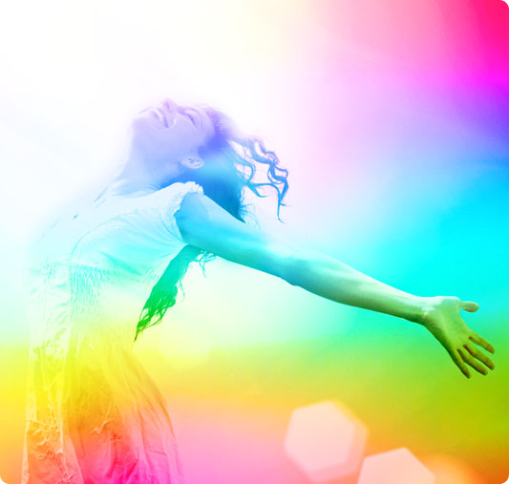

Would you like to harness
the power and confidence
to stand up and speak out for yourself?
Discover how to build
a ‘bridge over troubled waters’ of the stories of your past.
Rewrite a new story using
Feldenkrais movements and sound to rewire your brain.
Book NOW!
for a FREE Discovery Session with Rhonda Ohlson
Mobile: 0439 352 521
Email: womanshine @gmail.com

