Turn your pain into power
Align your body and tune up your voice
Build your rainbow bridge with Feldenkrais movements and sound.
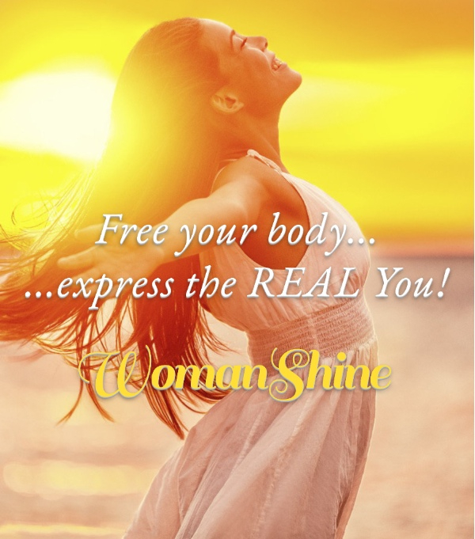

Red Bridge – Switch on the ring muscles in the feet and pelvic floor. Place hands just above your public bone. Bend your knees and breathe in. Straighten your knees and breathe out as you engage pelvic floor muscles. Purse your lips as if blowing out a candle. Make “oo” sound.
Orange Bridge –Free your pelvis with pelvic rock movements. Place your hands on your lower belly and breath in. Breathe out and push your belly out, sounding a tiger roar with the sound “moo.”
Yellow Bridge –Move your ribs to play your rib accordion with see saw breathing. Place one hand on your lower belly and one hand on your chest. Hold your breath and push the air from your chest to your lower belly. Sound ‘shh’ kkk’ ‘zzz’ and push out your ribs. Place your hands on your lower ribs and push your ribs out and sound “voo.”
Green Bridge- Open your heart by spiralling your arms. Do the Reptile Dance making ‘ah’ sounds.
Blue Bridge – Free your jaw, lips and tongue with sounds a baby makes. ‘brr,’ ‘ng,’ yawn, hum, sigh.
Indigo Bridge – Free your eyes so that you can see clearly and breathe freely. Move your eyes and head in opposite directions. Place your hands over your eyes and sound ‘Aum’
Violet Bridge– Open your ears to hear the voice of your spirit. Hold your lower jaw and move your skull as if to look up to the ceiling. Move your skull left and right and then in an arc. Make a humming sound.
Here is link to video https://youtu.be/BavDzUnAAUQ

